In the sensor connection section, we just need to connect 4 port,

GND from MLX to GND on TFT Feather

VCC from MLX to 3V on TFT Feather

SDA from MLX to SDA TFT Feather

SCL from MLX to SCL TFT Feather

Before using Arduino IDE upload the code,

1. make sure your develop board and screen are work
2. Make sure your board and the screen can run the TFT_eSPI library (if u don’t know how to make it, please read the other word documents in the same file).
3. Download and copy the MLX90641 library to the Arduino library file (<https://github.com/Seeed-Studio/Seeed_Arduino_MLX9064x/archive/master.zip>)
4. Test the board and the sensor (<https://wiki.seeedstudio.com/Grove-Thermal-Imaging-Camera-IR-Array/#features>)

Then go to the Files, follow the path working channel > Resource of the project > CODE and open project code.txt, copy the code into Arduino IDE and upload it.

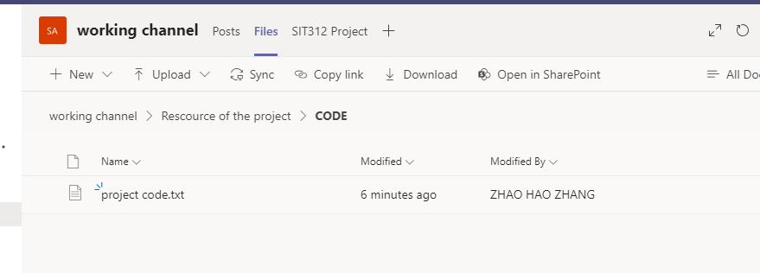

Code is modified base on the code from the seeed <https://wiki.seeedstudio.com/Grove-Thermal-Imaging-Camera-IR-Array/#features>